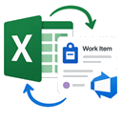  ADO in Excel  Frequently Asked Questions  Connect. Refresh. Edit. Publish. | AZURE DEVOPS  +  EXCEL

Purpose
This FAQ explains how to use the ADO in Excel extension and Office.js add-in to load Azure DevOps work items into Excel, maintain them in bulk, and publish updates back to Azure DevOps. It also covers tree structures, columns, assignments, links, attachments, comments, and common troubleshooting steps.

At a glance
1 | 2 | 3 | 4
Load a saved query | Edit in Excel | Refresh or publish | Manage details

Who should use it?
- Project managers and delivery leads maintaining large work-item sets
- Team leads and developers performing status or assignment updates
- Business analysts organizing backlog structures and query results
- Anyone who prefers Excel filtering, sorting, formulas, and bulk editing

Supported operating model
Use Excel for Windows with Microsoft 365. Open a bound workbook created from Azure DevOps, connect the add-in using Microsoft Entra ID or a Personal Access Token (PAT), then use Refresh and Publish to synchronize data.

Visual quick-start guide
Follow this sequence to move from an Azure DevOps query to reviewed, published updates in Excel.
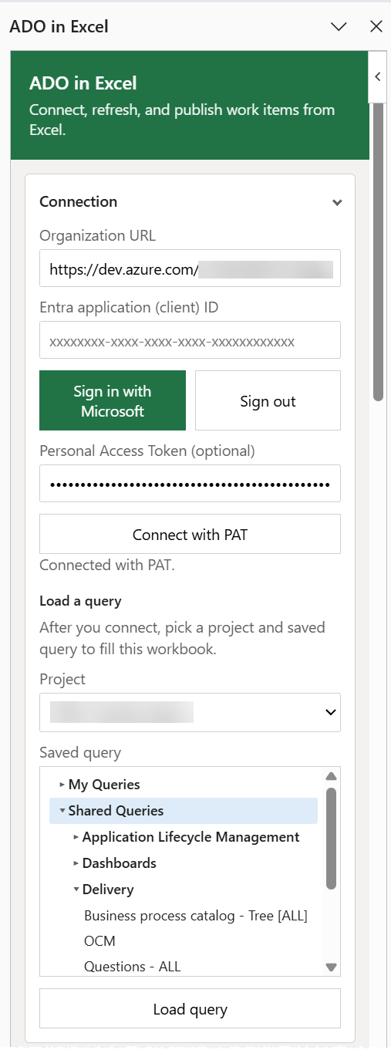  Enter the organization URL. Sign in with Microsoft Entra ID or connect with a PAT. | Select the project and a saved query, then choose Load query. | 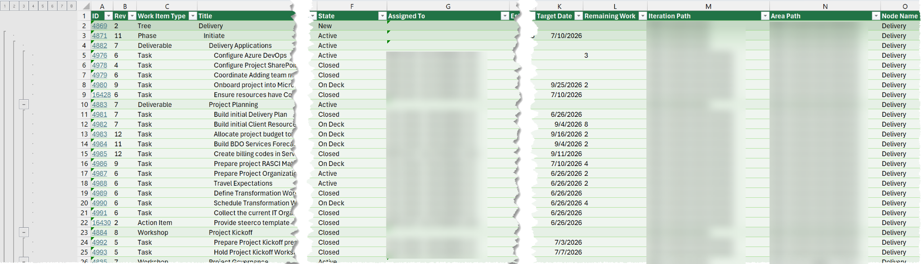  Confirm the loaded IDs, work item types, titles, states, assignments, paths, and dates.
  1 | Connect
  2 | Load a saved query
  3 | Review the workbook
↓ ↓ ↓
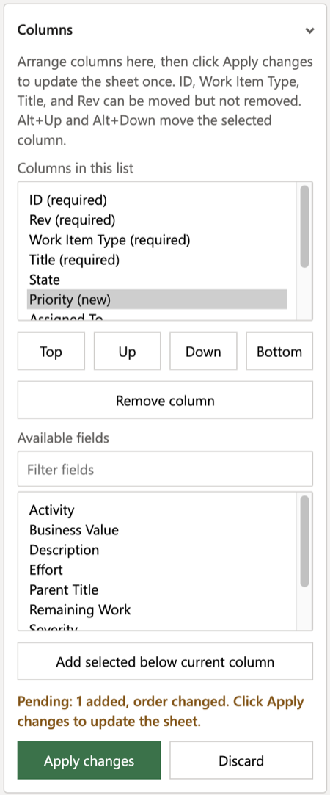  Use Excel tools for bulk edits. Add columns, insert work items, or maintain a tree hierarchy. | 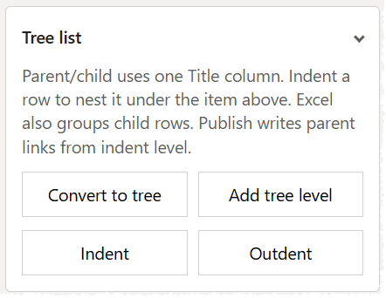  Check required fields, valid picklist values, assignments, paths, hierarchy, and the intended rows. | 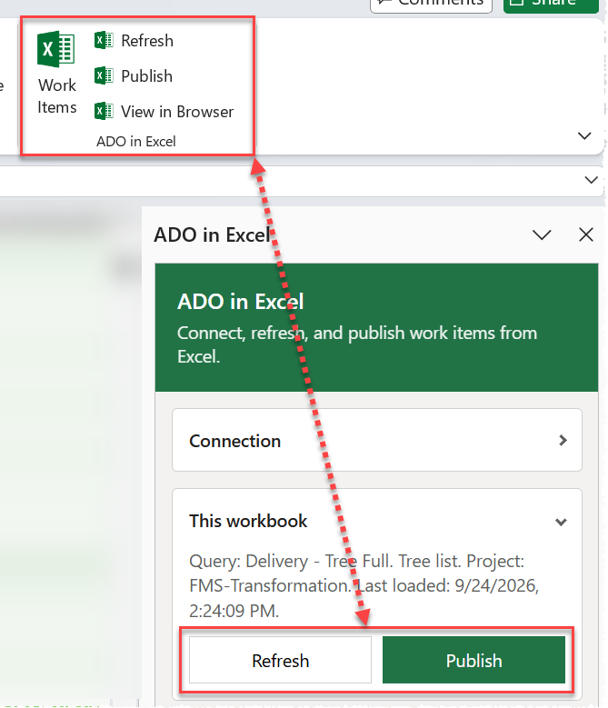  Refresh retrieves current Azure DevOps values. Publish sends reviewed worksheet changes back.
  4 | Edit and organize
  5 | Validate the changes
  6 | Refresh or publish
Recommended sequence: Refresh before editing when the workbook may be stale. Review the affected rows and fields, publish a small batch first for high-impact changes, and spot-check the results in Azure DevOps.

Detailed quick start
1. Open ADO in Excel  From Azure DevOps, start from a saved query, query results, or selected work items. Choose ADO in Excel, build the workbook, and select Download workbook. The browser downloads an .xlsx file rather than launching Excel directly. | Screenshot reference: 2.Connection.png

2. Open the workbook
Open the downloaded workbook in Excel for Windows. If Protected View appears, select Enable Editing. The worksheet already contains the query data; binding metadata remains hidden.

Screenshot reference: 1.ExcelView.png
3. Connect the add-in  Open the ADO in Excel task pane. Enter the organization URL and connect with Microsoft Entra ID or a PAT. Select the project and saved query, then choose Load query. | Screenshot reference: 2.Connection.png

4. Maintain work items  Filter, sort, edit fields, insert work items, manage hierarchy, change columns, assign people, and update Area Path or Iteration Path. | Screenshot reference: 6.Columns.png

5. Refresh or publish  Refresh reloads current values from Azure DevOps. Publish writes supported worksheet changes back to Azure DevOps. Use the ribbon or the This workbook section. | Screenshot reference: 3.ThisWorkbook.png

Core FAQ
1. What is ADO in Excel?
ADO in Excel is an Azure DevOps extension plus an Excel Office.js add-in. It creates a bound workbook from Azure DevOps work items, supports editing in Excel, and publishes supported changes back to Azure DevOps.
2. Is this the same as the classic Azure DevOps Open in Excel capability?
It serves a similar business purpose but uses a modern Office.js add-in rather than the legacy COM add-in. The workbook is downloaded first, then opened in Excel.
3. What platform is supported?
Excel for Windows in Microsoft 365 is the supported target. Browser-based Excel and Excel for Mac are not the intended operating model for this solution.
4. How do I sign in?
Use either Microsoft Entra ID or a Personal Access Token (PAT). Entra ID requires the configured application client ID. PAT authentication requires appropriate Azure DevOps scopes and should follow organizational security policy.
5. What does Load query do?
After connection, select a project and a saved query. Load query fills the workbook with the query results and retains the workbook binding needed for later refresh and publish operations.
Important: Use a saved query. Unsaved and some built-in queries are not supported.
6. What is the difference between Refresh and Publish?
Refresh reloads current values from Azure DevOps into the workbook. Publish sends supported worksheet changes to Azure DevOps. Refresh before editing when the workbook may be stale, and publish after reviewing the intended changes.
7. Can I use the Excel ribbon instead of the task pane?
Yes. The ADO in Excel ribbon group provides Work Items, Refresh, Publish, and View in Browser commands. The task pane also provides Refresh and Publish under This workbook.
8. Can I edit many work items at once?
Yes. Use standard Excel techniques such as fill handle, copy and paste, filtering, and sorting. Publish only after validating the affected rows and fields.
Important: A sheet remains tied to the organization from which it was loaded. Connect to the same organization before refreshing or publishing.

Working with work items
9. How do I insert a new work item?
Expand Insert work item, choose a work item type, and select Insert work item. Complete the new row in Excel, then publish. Work item types and states come from the selected project process template.
10. Can I create or maintain a parent-child hierarchy?
Yes. Convert the list to a tree when needed, then use Indent and Outdent. The tree uses one Title column, Excel row grouping, and indentation to represent levels. Publishing writes parent links based on the hierarchy.
11. How do I add, remove, or reorder columns?
Expand Columns. Select existing columns to move or remove, select fields from Available fields to add, then choose Apply changes. ID, Revision, Work Item Type, and Title can be moved but not removed.
12. How do I change Area Path or Iteration Path?
Select a cell in the Area Path or Iteration Path column. In the task pane, filter and choose a valid node from the project tree, then select Apply area path or Apply iteration path.
13. How do I change Assigned To?
Use the worksheet dropdown when the person is listed. If not, use the Assigned To section to search by name or email, select the person, and apply the value to the selected cell.
14. How do I open a work item in Azure DevOps?
Select a row with an existing ID and use the ID hyperlink, View in Browser on the ribbon or cell menu, or Open in Azure DevOps in the task pane. Publish new rows before trying to open them.
15. How do I manage related links?
Select a row and choose Load details. Review existing links, add a work item ID and link type, or remove a selected link. Supported options include related, predecessor, and successor links.
16. How do I add attachments or comments?
After loading details for the selected row, use Attachments to choose and attach a file. Use Discussion to enter a comment and select Add comment. Reload details after selecting a different row.

Task-pane reference
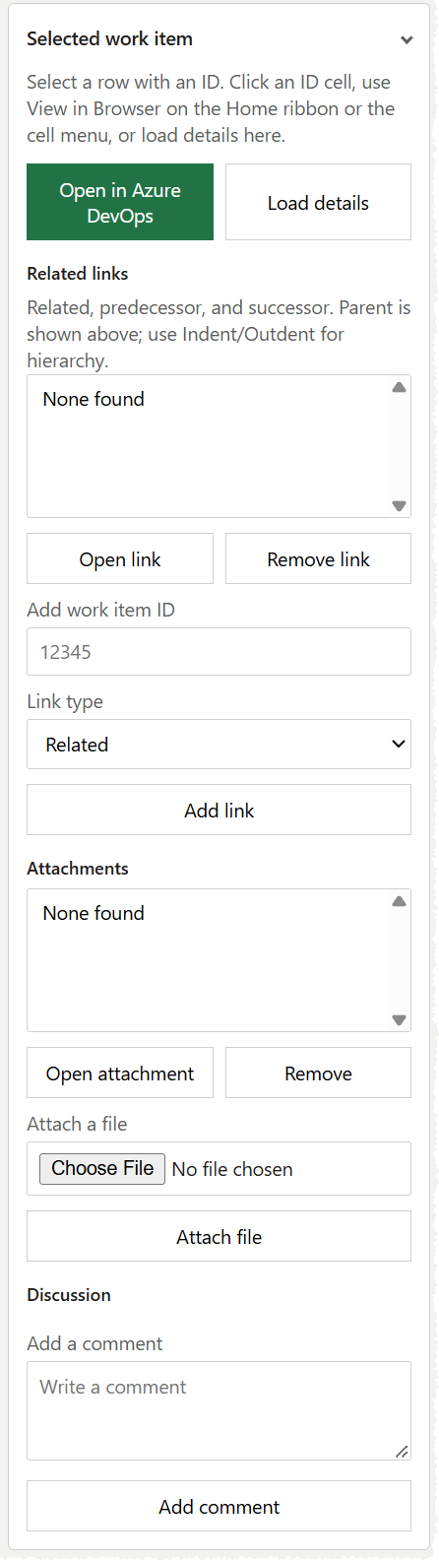 | 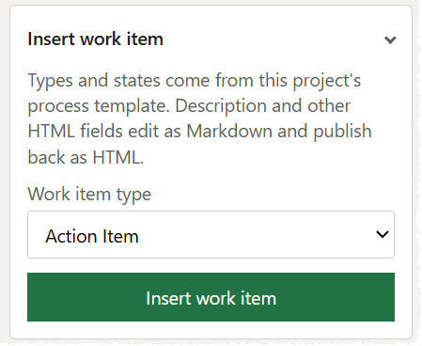 |  | 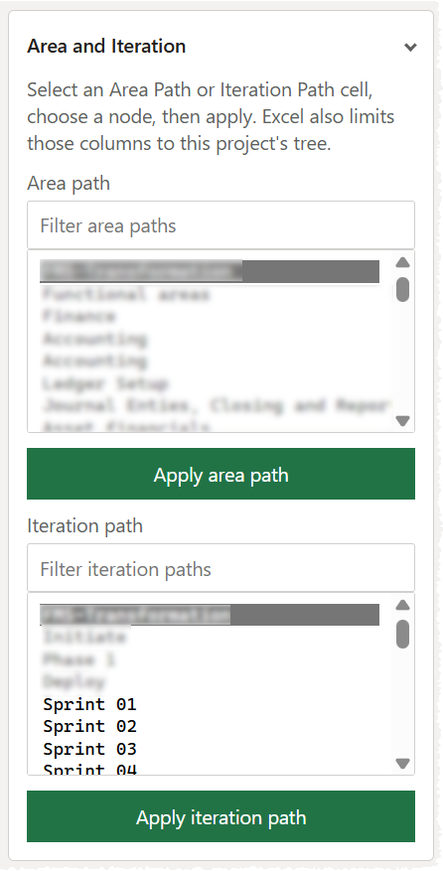
Links, files, comments | Insert work item | Tree hierarchy | Area and iteration

Troubleshooting and good practices
17. Why can’t I load a query?
Confirm that the add-in is connected, the correct project is selected, and the query is saved and accessible to the signed-in user. Expand query folders such as My Queries or Shared Queries, select the query, and try again.
18. Why is Publish unavailable or unsuccessful?
Confirm that the workbook is bound, the add-in is connected to the same organization, and the account has permission to edit the affected work items. Also check for invalid states, required fields, restricted picklist values, or stale revisions.
19. Why did Refresh replace worksheet values?
Refresh retrieves current Azure DevOps values. Treat uncommitted worksheet edits as temporary. Publish validated edits before refreshing, or save a separate workbook copy if analysis-only changes must be retained.
20. Why does View in Browser not work for a new row?
A new row has no Azure DevOps work item ID until successfully published. Publish the row first, then use View in Browser.
21. Why is a person missing from Assigned To?
The in-cell dropdown is populated from the project teams and people already present on the sheet. Use the Assigned To search in the task pane for other valid users.
22. How are Description and other HTML fields handled?
HTML-backed fields can be edited as Markdown in Excel and are converted when published. Pasted HTML can be published as HTML. Review formatting after publish when content includes complex markup.
23. Can I change an existing work item’s type?
Changing Work Item Type for an existing item is not supported. Create a new item of the correct type or make the change directly in Azure DevOps if the process permits it.
24. What should I do before a large publish?
Use a controlled sequence:
- Refresh to establish current values.
- Filter to the intended records and fields.
- Review IDs, states, assignments, paths, dates, and hierarchy.
- Publish a small batch first when the change is high impact.
- Confirm the status message and spot-check results in Azure DevOps.

Recommended operating checklist
Before editing  Confirm organization, project, query, and last-loaded timestamp. Refresh if needed. | During editing  Use valid picklist values and preserve required identifiers and columns.
Before publishing  Filter and review the exact rows being changed. Validate hierarchy and required fields. | After publishing  Read the status message, refresh if appropriate, and spot-check selected work items in Azure DevOps.

